Sprint 3 - Agility Design Document

December 2, 2021

Group 1

Kristina Shaw, Andrew McGovern, Michael Ivanicki

Table of Contents
1. Executive Summary 3
1.1 Project Overview 3
1.2 Purpose and Scope of this Specification 3
2. Product/Service Description 3
2.1 Product Context 3
2.2 User Characteristics 3
2.3 Assumptions 3
2.4 Constraints 3
2.5 Dependencies 4
3. Requirements 4
3.1 Functional Requirements 5
3.2 Security 5
3.2.1 Protection 5
3.2.2 Authorization and Authentication 5
3.3 Portability 5
4. Requirements Confirmation/Stakeholder sign-off 6
5. System Design 6
5.1 Algorithm 6
5.2 System Flow 6
5.3 Software 6
5.4 Hardware 6
5.5 Test Plan 6
5.6 Task List/Gantt Chart 6
5.7 Staffing Plan 7

Executive Summary

Project Overview

The Sphero robot is an excellent way for consumers to learn and fully understand the fundamentals of computer programming.
These projects, using the Sphero robot and Sphero Edu software, intend to allow the robot to complete the rectangular course, figure-8 course, and obstacle course all as quickly and accurately as possible and communicate our results to the Sphero consumers.

Purpose and Scope of this Specification

With our presented program, the consumer will be able to:
In Scope
- Have their robot complete the Agility course: an obstacle course

Out of Scope
- Have their Sphero robot complete the Endurance course: a rectangular perimeter around a room or flat surface
- Have their robot complete the Accuracy course: a figure eight pattern

Product/Service Description

Product Context

This product is the third of three Sprints, the third of four parts, to the Software Development Project. A diagram of the overall Software Development Project can be seen below.
Software Development Project
Sprint 1:  Endurance | Sprint 2:  Accuracy | Sprint 3:  Agility | Part 4:  Presentation

User Characteristics

This product pertains to users that fall under one or more of the following:
- Students and Faculty
  - Minimal experience required
  - Need to understand how to navigate the Sphero Edu software / application
- New or current programmers or Sphero users
  - Minimal experience required
  - May need experience in block coding if attempting to learn or edit program

Assumptions

The user is assumed to have:
- A computer, smart phone, tablet, or other smart device
- A Sphero robot
- The Sphero Edu application downloaded
- Access to the predetermined obstacle course for which the program is designed

Constraints

The following are possible constraints to the creation and design of the presented project:
- Room / space availability and access for testing the program
- Conflicting schedules of team members preventing meeting up

The following are possible constraints to the use of the presented project:
- Room / space availability and access for running the program on predetermined obstacle course
- Smart device current software status
- Smart device storage capacity

Dependencies

The following are dependencies in which will affect the run of the program:
- Room / floor space availability for the robot to move around
- Ability to download or recreate this product’s block code
- Access to a charged and functional Sphero robot

Requirements

Functional Requirements

Req# | Requirement | Comments | Priority | Date Rvwd | SME Reviewed / Approved
AGIL_01 | Robot starts on the X |  | 1 | 11/23/21 | AM
AGIL_02 | Blue alignment light starts in the opposite direction of the initial direction | Not explicitly required, but initial alignment is needed to start movement in correct direction | 2 | 11/23/21 | AM
AGIL_03 | Robot travels to first corner and avoids hitting bottle | Breaking up the abstract requirement “The robot will encounter 3 objects which it must avoid” | 1 | 11/23/21 | AM
AGIL_04 | Robot stops at the first corner | Not explicitly required but must happen for the robot to stay on the track | 2 | 11/23/21 | AM
AGIL_05 | Robot travels to second corner and avoids hitting bottle |  | 1 | 11/23/21 | AM
AGIL_06 | Robot stops at the second corner | Not explicitly required but must happen for the robot to stay on the track | 2 | 11/23/21 | AM
AGIL_07 | Robot travels to third corner and avoids hitting bottle |  | 1 | 11/23/21 | AM
AGIL_08 | Robot stops at the third corner | Not explicitly required but must happen for the robot to stay on the track | 2 | 11/23/21 | AM
AGIL_09 | Robot travels straight and goes up the ramp |  | 1 | 11/23/21 | AM
AGIL_10 | Robot falls off the ramp and lands on the track and stops | It would be nice to have the robot stop at the bottom of the ramp so it could stabilize after falling off the ramp | 3 | 11/23/21 | AM
AGIL_11 | Robot continues to the next corner after the ramp |  | 1 | 11/23/21 | AM
AGIL_12 | Robot stops at the next corner | Not explicitly required but must happen for the robot to stay on the track | 2 | 11/23/21 | AM
AGIL_13 | Robot travels straight towards the pins |  | 1 | 11/23/21 | AM
AGIL_14 | Robot knocks over as many pins as possible | Attempting to knock over all the pins | 1 | 11/23/21 | AM

Security

Protection

The security measure that our team took to ensure the protection of our data and code was that our project files were only saved on devices with passwords. This was to ensure that nobody outside of our group could access our work and potentially alter what we had done. Any files related to the project were saved on these secure devices and all access to files or code were restricted to private, so that only we could see and access them.
Because this program is simply for a class project, no extra security measures designed by our team are required for protection from malicious intent.

Authorization and Authentication

To run the program, a user must be logged into a smart device that has the Sphero Edu application, and they must log into Sphero Edu as well to access an account that has access to the block code.
The original block code program is on Sphero Edu account: drewmcgovern

Portability

The smart devices (computers, phones, etc.) that run the Sphero Edu application are portable, the Sphero robot is portable, and the block code is portable to other smart devices from the host device as well.
While the device running the code and the robot are both portable, they must be connected to each other via Bluetooth while the program is running, so the device and the robot must be in close proximity with each other.
The predetermined obstacle course track for the project is not portable as it can only be found on the floor of Howard Hall Room 208.

Requirements Confirmation/Stakeholder sign-off

Meeting Date | Attendees (name and role) | Comments
11/23/21 | Kristina Shaw | Confirmed all
11/23/21 | Michael Ivanicki | Confirmed all
11/23/21 | Andrew McGovern | Confirmed all

System Design

Algorithm

- Start program
- Roll forward at 0 degrees at a set speed and set time
- Stop rolling and delay
- Roll to the right at a set degree at a set speed and set time
- Stop rolling and delay
- Roll to the left at a set degree at a set speed and set time
- Stop rolling and delay
- Roll to the right and over the ramp at a set degree at a set speed and set time
- Stop rolling and delay
- Roll right to the corner at a set degree at a set speed and set time
- Stop rolling and delay
- Roll towards the pins at a set degree at a set speed and set time
- Stop rolling
- End program

System Flow
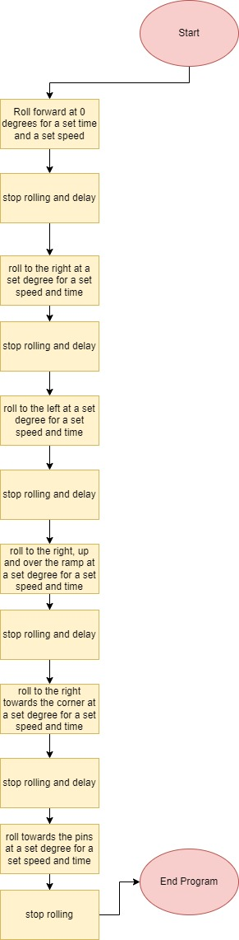

Software

The main software used for this project is the Sphero Edu application. This software is how our team constructed and edited the code, connected to the robot, and ran the program with the robot.
We also used Windows, Mac, Linux, and iOS operating systems to use the Sphero Edu application. These operating systems allowed us to download and install the Sphero Edu application, so these were also vital aspects of our project as well.
The block code for the project is embedded below.
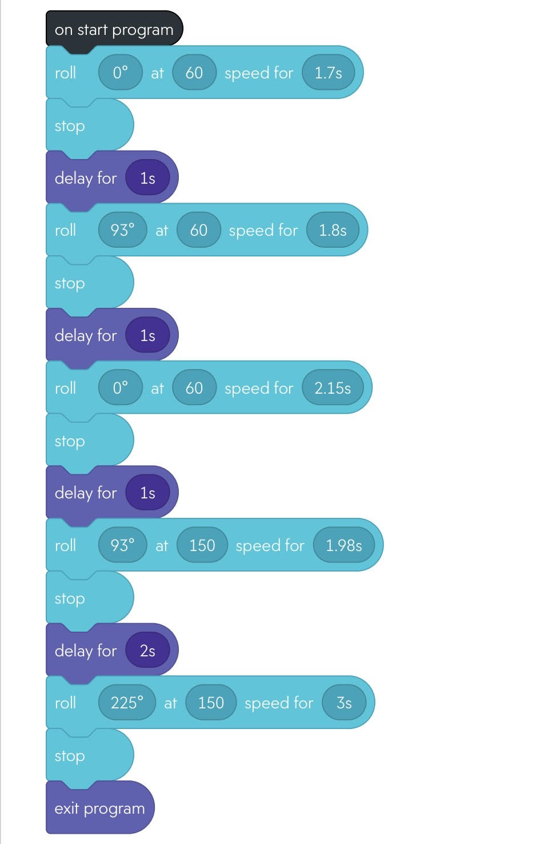

The Sensor Data Diagram is embedded below.

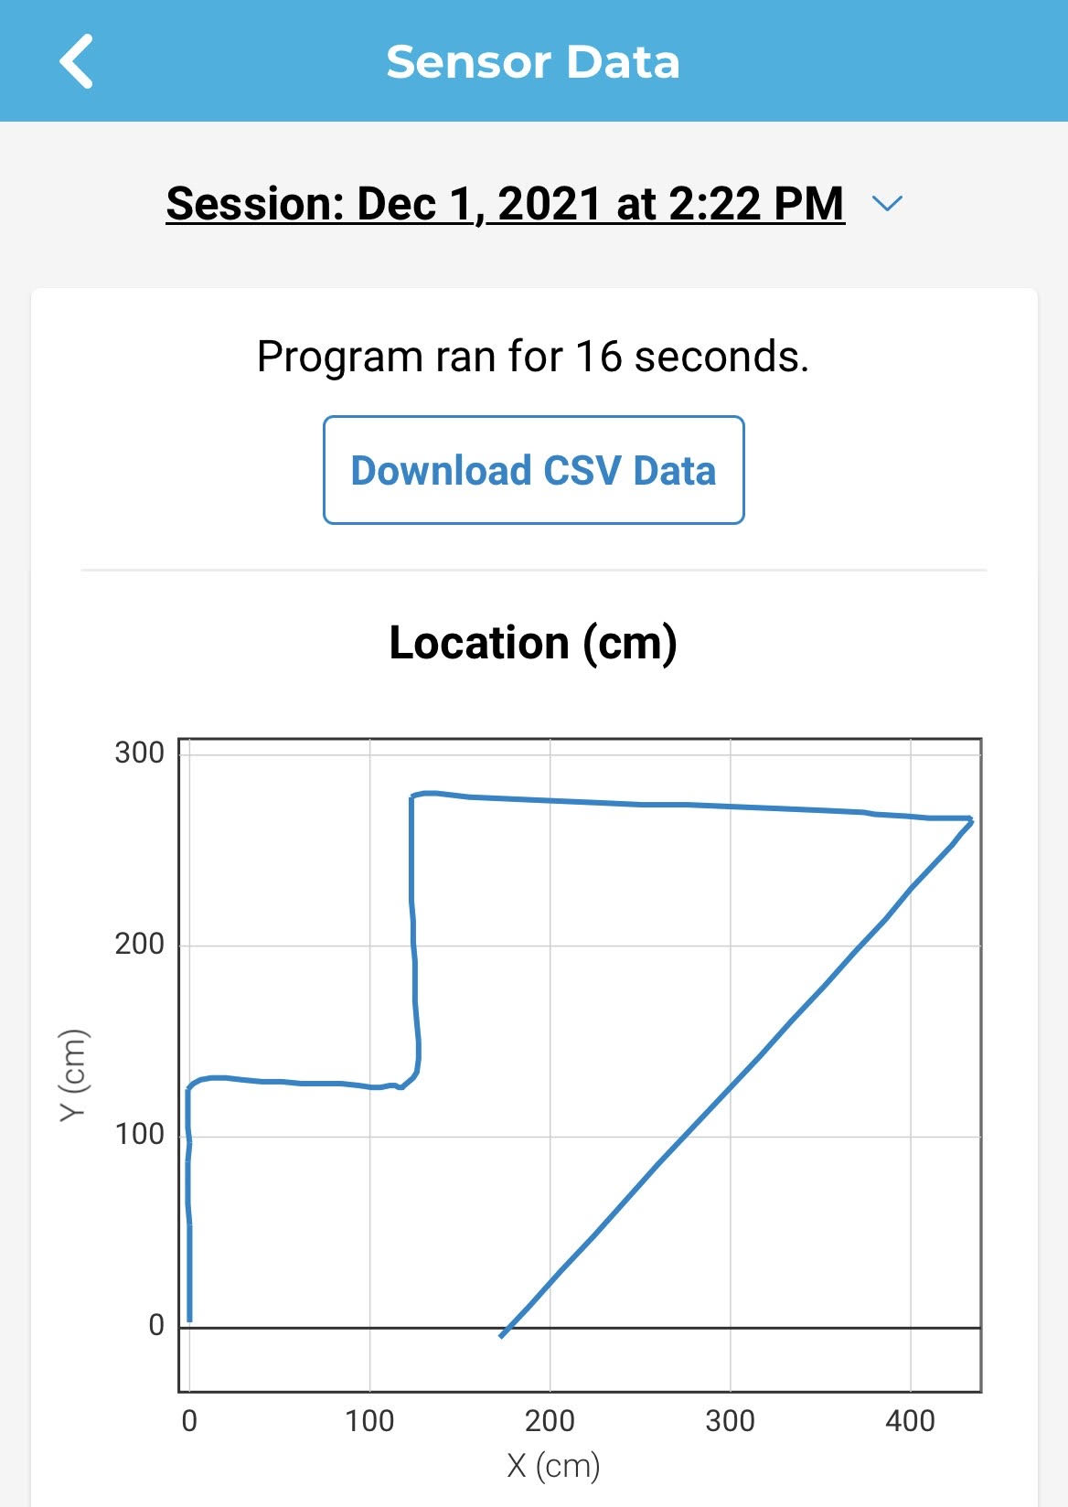

Hardware

The main hardware devices we used to run the software and develop the project were laptops and phones. We used both device types to run the software mentioned in the previous section, in order to complete the project. Specifically, it allowed us to construct and test the code and to wirelessly connect with our robot, but all aspects of the project can be attributed to the hardware, since we would not have been able to complete any of the tasks without the hardware.
Also, the Sphero robot and charging station were obviously essential to the completion of the project, as a functional and powered Sphero robot is needed in order to run the program.

Test Plan

Reason for Test Case | Test Date | Expected Output | Observed Output | Staff Name | Pass/Fail
Testing for first length at 0 degrees at 60 speed for 2 seconds | 11/30 | Robot reaches the first corner and stops | Robot overshot the first corner | AM | Fail
Testing for first length at 0 degrees at 60 speed for 1.5 seconds | 11/30 | Robot reaches the first corner and stops | Robot overshot the first corner | AM | Fail
Testing for first length at 0 degrees at 60 speed for 1.7 seconds | 11/30 | Robot reaches the first corner and stops | Robot successfully reached the first corner | AM | Pass
Testing for second length at 90 degrees at 60 speed for 2 seconds | 11/30 | Robot reaches the second corner and stops | Angle of turn was too narrow and the robot went off track | AM | Fail
Testing for first length at 95 degrees at 60 speed for 2 seconds | 11/30 | Robot reaches the second corner and stops | Angle of turn was too wide and the robot hit the second bottle | AM | Fail
Testing for second length at 93 degrees at 60 speed 2 seconds | 11/30 | Robot reaches the second corner and stops | Angle was correct, robot traveled slightly too far | AM | Fail
Testing for second length at 93 degrees at 60 speed 1.9 seconds | 11/30 | Robot reaches the second corner and stops | Robot still traveled slightly too far on the second length | AM | Fail
Testing for second length at 93 degrees at 60 speed 1.8 seconds | 11/30 | Robot reaches the second corner and stops | Robot successfully completed the first two lengths together | AM | Pass
Testing for third length at 0 degrees at 60 speed 2 seconds | 11/30 | Robot reaches the third corner and stops | Robot slightly undershot the third corner | AM | Fail
Testing for third length at 0 degrees at 60 speed 2.1 seconds | 11/30 | Robot reaches the third corner and stops | Robot still slightly undershot the third corner | AM | Fail
Testing for third length at 0 degrees at 60 speed 2.15 seconds | 11/30 | Robot reaches the third corner and stops | Robot successfully reached the end of the third length | AM | Pass
Testing for fourth length, over the ramp, at 93 degrees at 60 speed for 3 seconds | 11/30 | Robot goes over the ramp and reaches the fourth corner at the end of the fourth length | Robot did not have enough speed to make it over the ramp | AM | Fail
Testing for fourth length, over the ramp, at 93 degrees at 100 speed for 3 seconds | 11/30 | Robot goes over the ramp and reaches the fourth corner at the end of the fourth length | Robot still did not have enough speed to make it over the ramp | AM | Fail
Testing for fourth length, over the ramp, at 93 degrees at 150 speed for 3 seconds | 11/30 | Robot goes over the ramp and reaches the fourth corner at the end of the fourth length | Robot had enough speed to go over the ramp, but 3 seconds was much too long, robot overshot corner | AM | Fail
Testing for fourth length, over the ramp, at 93 degrees at 150 speed for 2 seconds | 12/1 | Robot goes over the ramp and reaches the fourth corner at the end of the fourth length | Robot got over the ramp and just slightly overshot the fourth corner | AM | Fail
Testing for fourth length, over the ramp, at 93 degrees at 150 speed for 1.95 seconds | 12/1 | Robot successfully completes the course and meets all the requirements with lights and sounds | Robot got over the ramp and just slightly undershot the fourth corner | AM | Fail
Testing for fourth length, over the ramp, at 93 degrees at 150 speed for 1.98 seconds | 12/1 | Robot successfully completes the course and meets all the requirements with lights and sounds | Robot got over the ramp and just successfully stopped at the fourth corner | AM | Pass
Testing for the fifth length towards the pins at 250 degrees at 150 speed for 2 seconds | 12/1 | Robot successfully completes the full course | The turn was too narrow and the robot did not stay on track for the final length | AM | Fail
Testing for the fifth length towards the pins at 225 degrees at 150 speed for 2 seconds | 12/1 | Robot successfully completes the full course | Robot had the correct angle but 2 seconds was not long enough to reach the pins | AM | Fail
Testing for the fifth length towards the pins at 250 degrees at 150 speed for 3 seconds | 12/1 | Robot successfully completes the full course | Robot successfully completed the course, avoided obstacles and went over the ramp, and knocked over some pins at the end | AM | Pass
Testing for a full successful run where all the pins are knocked down | 12/1 | Robot successfully completes the full course knocking down all the pins | All but two pins were knocked down | AM | Fail
Testing for a full successful run where all the pins are knocked down | 12/1 | Robot successfully completes the full course knocking down all the pins | The obstacle course was completed and all of the pins were knocked down | AM | Pass

Task List/Gantt Chart

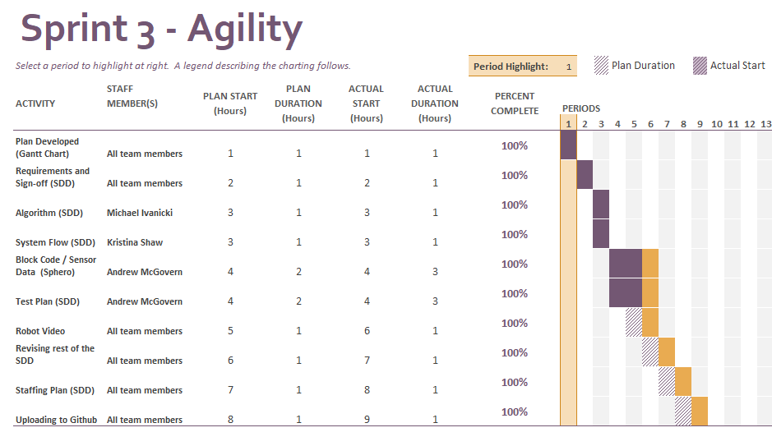

Staffing Plan

Name | Role | Responsibility | Reports To
Andrew McGovern | Subject-matter Expert, Team Programmer, Test Plan Manager | Understood requirements and took charge of the requirements table and the SDD and the Gantt Chart, took charge of the main device used for programming, track the test plans and outcomes | Prof. Eckert
Kristina Shaw | Team Manager, Product Communicator, Video Manager | Organized meeting times and scheduling, took charge of Executive Summary and Product Service / Description, recorded robot during test runs | Prof. Eckert
Michael Ivanicki | Algorithm Manager, Device expert, Video Manager | Took charge of algorithm and planning for code, took charge of Software, Hardware, and Security Descriptions, recorded robot during test runs | Prof. Eckert

